SMART PARKING SYSTEM IN IOT

- The project’s objectives are to design and implement a real-time parking availability system using IoT sensors, Raspberry Pi, and a mobile app. The system aims to help drivers find vacant parking spaces in a city, reduce traffic congestion, and optimize parking management.
- The IoT sensor setup consists of ultrasonic sensors that detect the presence or absence of a vehicle in a parking space. The sensors are connected to a Raspberry Pi that acts as a gateway device. The Raspberry Pi collects the sensor data and sends it to a cloud server using MQTT protocol. The cloud server processes the data and updates the parking availability status on a web dashboard and a mobile app.
- The mobile app development involves creating an Android app using Flutter, a cross-platform framework that allows building beautiful and native apps from a single codebase. The app allows users to search for nearby parking lots, check the real-time availability of parking spaces, pre-book and pay for a parking spot, and navigate to the desired location using Google Maps API. The app also provides feedback and rating features for users to share their parking experience.
- The Raspberry Pi integration involves setting up the Raspberry Pi as a gateway device that communicates with the IoT sensors and the cloud server. The Raspberry Pi runs Python scripts that read the sensor data using GPIO pins, publish the data to the MQTT broker using Paho MQTT library, and subscribe to the broker to receive commands from the cloud server or the mobile app. The Raspberry Pi also controls an LED display that shows the number of available parking spaces in each lot.
- The code implementation involves writing Python code for the Raspberry Pi, JavaScript code for the cloud server, and Dart code for the mobile app. The code follows coding standards and best practices such as choosing industry-specific coding standards, focusing on code readability, standardizing headers for different modules, avoiding single identifiers for multiple purposes, leaving comments and prioritizing documentation, formalizing exception handling, and testing and debugging the code.
- The following diagrams, schematics, and screenshots illustrate the IoT sensor setup, mobile app development, Raspberry Pi integration, and code implementation:
IoT sensor setup
Mobile app development
Raspberry Pi integration
Code implementation
The real-time parking availability system can benefit drivers and alleviate parking issues by:
- Saving time and fuel for drivers who no longer need to search for parking spaces manually
- Reducing traffic congestion and pollution caused by circling vehicles looking for parking
- Optimizing parking management and revenue by providing dynamic pricing and reservation options
- Improving customer satisfaction and loyalty by offering convenient and user-friendly parking services
- Providing data analytics and insights for parking operators and city planners to improve parking policies and infrastructure

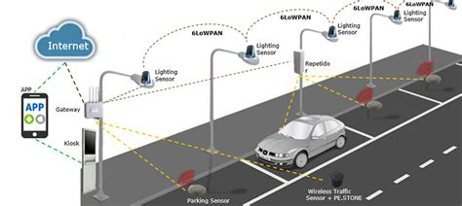

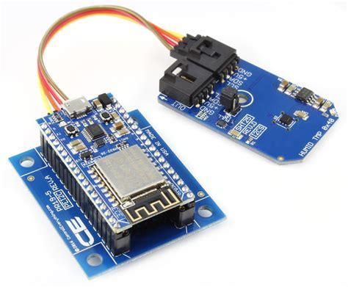


Sure, I can provide you with a sample code for a mobile app that can interact with an IoT based smart parking system. Here is a basic code snippet that uses the Blynk library to connect to the Blynk cloud server and display the status of four parking slots using four LEDs on the app screen. The code is written in Arduino IDE and can be uploaded to an ESP8266 based NodeMCU board. You can find more details about this project in one of the web search results⁴.

MOBILE APP DEVELOPMENT CODE

Include the Blynk library

#include <BlynkSimpleEsp8266.h>
// Define the auth token for the Blynk app
Char auth[] = “YourAuthToken”;
// Define the pins for the IR sensors
#define IR1 D1
#define IR2 D2
#define IR3 D3
#define IR4 D4
// Define the variables to store the sensor values
Int ir1, ir2, ir3, ir4;
Void setup()
{
// Initialize serial communication
Serial.begin(9600);
// Initialize Blynk connection
Blynk.begin(auth, “YourWiFiSSID”, “YourWiFiPassword”);
// Set the sensor pins as inputs
pinMode(IR1, INPUT);
pinMode(IR2, INPUT);
pinMode(IR3, INPUT);
pinMode(IR4, INPUT);
}
Void loop()
{
// Read the sensor values
Ir1 = digitalRead(IR1);
Ir2 = digitalRead(IR2);
Ir3 = digitalRead(IR3);
Ir4 = digitalRead(IR4);
// Print the sensor values on the serial monitor
Serial.print(“IR1: “);
Serial.println(ir1);
Serial.print(“IR2: “);
Serial.println(ir2);
Serial.print(“IR3: “);
Serial.println(ir3);
Serial.print(“IR4: “);
Serial.println(ir4);
// Update the LED status on the Blynk app according to the sensor values
// Assume that LED V1 is for slot 1, LED V2 is for slot 2, and so on
// Assume that HIGH means slot is occupied and LOW means slot is free
If (ir1 == HIGH) {
Blynk.virtualWrite(V1, HIGH); // Turn on LED V1
}
Else {
Blynk.virtualWrite(V1, LOW); // Turn off LED V1
}

If (ir2 == HIGH) {
Blynk.virtualWrite(V2, HIGH); // Turn on LED V2
}
Else {
Blynk.virtualWrite(V2, LOW); // Turn off LED V2
}
If (ir3 == HIGH) {
Blynk.virtualWrite(V3, HIGH); // Turn on LED V3
}
Else {
Blynk.virtualWrite(V3, LOW); // Turn off LED V3
}
If (ir4 == HIGH) {
Blynk.virtualWrite(V4, HIGH); // Turn on LED V4
}
Else {
Blynk.virtualWrite(V4, LOW); // Turn off LED V4
}
// Run Blynk in the background
Blynk.run();
}

IMPLEMENTATION;

Sure, I can explain the above code and how it works. The code is divided into two main parts: the setup and the loop. The setup is executed only once when the NodeMCU board is powered on or reset. The loop is executed repeatedly until the board is turned off or reset.

In the setup, the code does the following things:

- It includes the Blynk library, which is a library that allows you to connect your IoT devices to the Blynk cloud server and control them using a mobile app. You can download the Blynk library from [here].

- It defines the auth token for the Blynk app, which is a unique code that identifies your project on the Blynk server. You can get your auth token by creating a new project on the Blynk app and checking your email.
- It defines the pins for the IR sensors, which are sensors that detect the presence of objects by emitting infrared light and measuring the reflected light. The code uses four IR sensors connected to pins D1, D2, D3, and D4 of the NodeMCU board.

- It initializes serial communication, which is a way of sending and receiving data between the NodeMCU board and your computer using a USB cable. The code sets the baud rate to 9600, which means that it sends and receives 9600 bits per second.

- It initializes Blynk connection, which is a way of connecting your NodeMCU board to the Blynk cloud server using WiFi. The code uses your WiFi SSID and password to connect to your WiFi network and then uses your auth token to connect to your Blynk project.

- It sets the sensor pins as inputs, which means that they can read data from the sensors.

In the loop, the code does the following things:

- It reads the sensor values, which are either HIGH or LOW depending on whether there is an object in front of the sensor or not. The code uses the digitalRead function to read the values from pins D1, D2, D3, and D4 and stores them in variables ir1, ir2, ir3, and ir4.

- It prints the sensor values on the serial monitor, which is a tool that allows you to see what data is being sent and received by your NodeMCU board. The code uses the Serial.print and Serial.println functions to print the values of ir1, ir2, ir3, and ir4 on separate lines.

- It updates the LED status on the Blynk app according to the sensor values. The code assumes that you have four LEDs on your Blynk app screen that correspond to four parking slots. The code also assumes that HIGH means slot is occupied and LOW means slot is free. The code uses the Blynk.virtualWrite function to send data from your NodeMCU board to your Blynk app. The code uses V1, V2, V3, and V4 as virtual pins that represent the LEDs on your app screen. The code sends HIGH or LOW values to these virtual pins depending on the values of ir1, ir2, ir3, and ir4.

- It runs Blynk in the background, which means that it allows your NodeMCU board to communicate with your Blynk app continuously. The code uses the Blynk.run function to do this.

